# Creating a Free Trial Azure Subscription

If you already have an Azure subscription, you can skip this section. Otherwise, follow these steps to create a free trial subscription. You will need to provide a valid credit card number for verification, but you will not be charged for Azure services.

◼ Note: Trial subscriptions grant access only for a limited time. You may want to initiate your free trial when you are ready to begin your first lab assignment. The free trial is not available in all regions.

For more information, visit the Azure free trial FAQ page at <https://aka.ms/edx-dat217-faq-az>.

If you already have a Microsoft account that has not already been used to sign up for a free Microsoft Azure trial subscription, you’re ready to get started. If not, don’t worry—just create a new Microsoft account at <https://signup.live.com>.

After you’ve created a Microsoft account, browse to <https://aka.ms/edx-dat217-az> and click the **Start now** button. Then follow the instructions to sign up for a free trial subscription to Microsoft Azure. You’ll need to sign in with your Microsoft account if you’re not already signed in. Then you’ll need to:

* Enter your cellphone number and have Microsoft send you a text message to verify your identity
* Enter the verification code sent to you
* Provide valid payment details—don’t worry, your credit card won’t be charged for any services you use during the trial period, and the account is automatically deactivated at the end of the trial period, unless you expressly request to keep it active.

# Provisioning an Azure VM

In this exercise, having signed in to the Azure Portal by using your Azure subscription, you will provision an Azure VM to support all three labs for this course.

**◼ Note:** The Azure VM will should be stopped (deallocated) at the end of each lab so that your subscription is not charged (for free trial subscriptions, this will ensure you will have sufficient credits left to complete the labs over the duration of the course).

## Provisioning an Azure VM

In this task, you will sign in to the Azure Portal, and then provision an Azure VM.

1. Sign in to the **Azure Portal** by using your subscription.
2. In the left pane, select **Virtual Machines**—do not select **Virtual Machines (Classic)**.

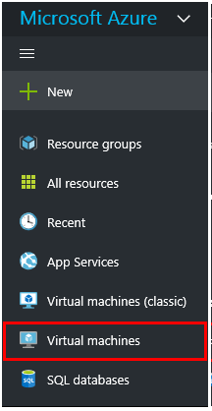

1. In the **Virtual Machines** blade, click **Add**.
2. 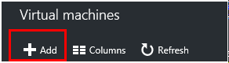
3. In the **Marketplace** blade, in the search box, enter **SQL Server 2016**, and then press **Enter**.
4. Select the **SQL Server 2016 RTM Enterprise on Windows Server 2012 R2** image.

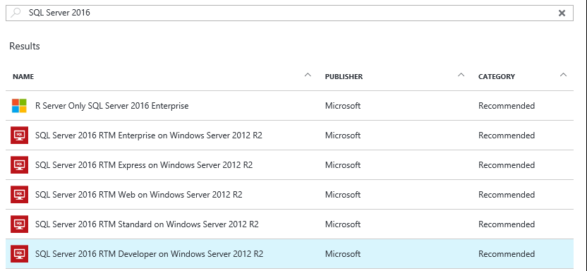

1. In the image blade, review the text content, and then click **Create**.



1. Notice that the **Create Virtual Machine** blade opens, and that also the **Basics** blade (step 1) opens.
2. In the **Name** box, enter a name for the virtual machine (this will become the name of the machine).
3. In the **User Name** and **Password** boxes, enter appropriate values (this will become the machine administrator account).

**◼ Note:** Be sure to securely record these credentials, as you will be required to use them to sign in to the VM for each lab over the next three weeks.

1. In the **Resource Group** box, select **Create new**, and enter a name for your resource group.
2. In the **Location** box, enter a data center that is in close proximity to you.
3. Click **OK**.



1. 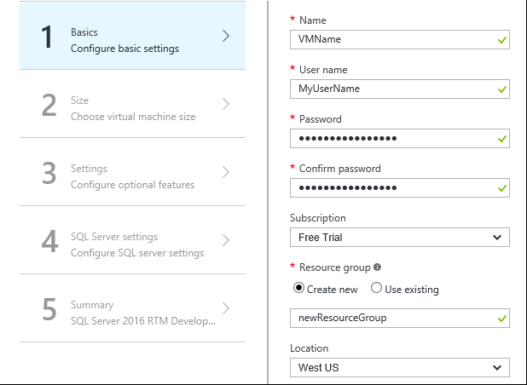
2. In the **Create Virtual Machine** blade, select **Size**.
3. In the **Choose a Size** blade, select from the sizes available to your subscription. The 3.5 GB option will be sufficient for this course.
4. Click **Select**.



1. 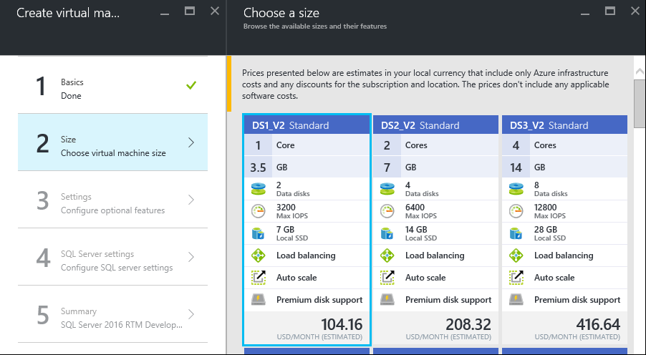
2. In the **Settings** blade, set the **Storage, Disk type** to **Standard**.

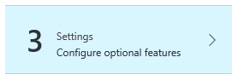

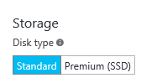

1. Set **Monitoring**, **Diagnostics** to disabled.

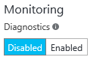

1. Click **OK**.



1. In the **Create Virtual Machine** blade, set **SQL Authentication** to Enable.

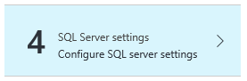

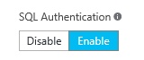

1. Click **OK**.



1. In the **SQL Server Settings** blade, click **OK**.



1. In the **Summary** blade, review the configuration, and then click **OK**.

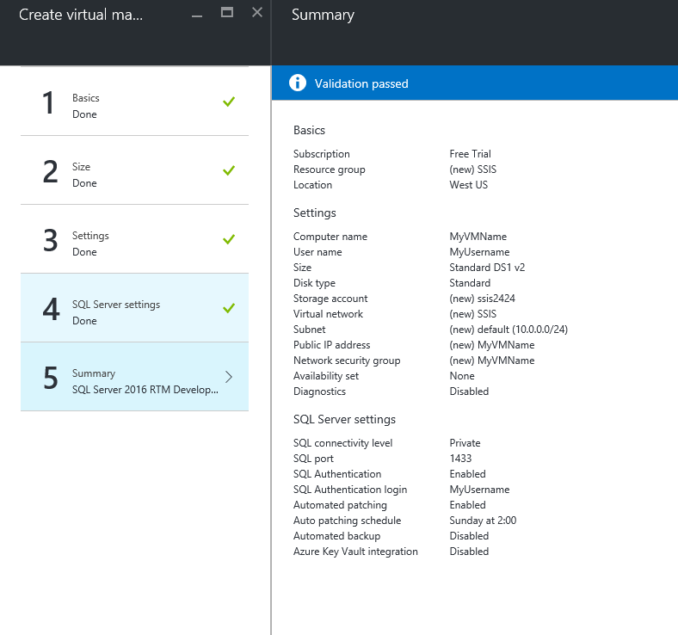

1. On the **Azure Portal** dashboard, notice the tile providing status of the deployment process.

The deployment usually takes 15-20 minutes to deploy, and this time depends largely on the VM size selected. The VM blade will open when the deployment completes.

You cannot proceed to the next task until the deployment completes.

1. Leave the **Azure Portal** dashboard open.

## Connecting to the VM

Once the VM has successfully deployed, you will connect to the VM.

**◼ NOTE:** You are charged when the VM status is **Running**, but you are not charged when the VM status is **Stopped (Deallocated)**. The labs will include steps to remind you to stop the VM.

1. To connect to the VM, click **Connect**.

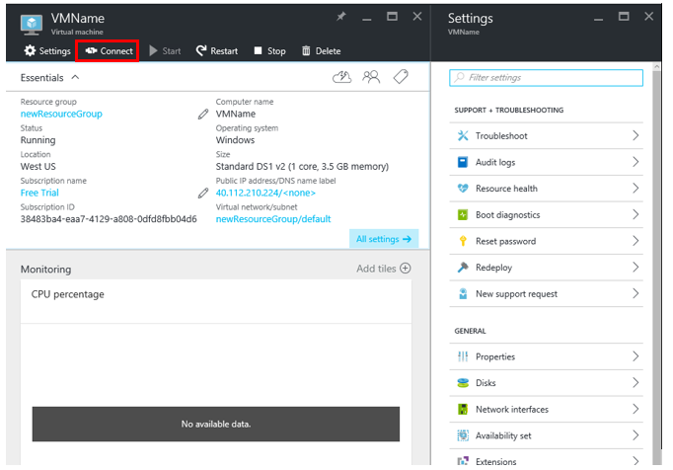

A Remote Desktop File (.rdp) file is downloaded to the desktop.

**◼ Note:** This file can be used to reconnect to the remote desktop session, but note that when you deallocate the VM and later re-start the VM, it will be likely that a different IP address will be assigned.

1. When prompted to open the Remote Desktop File, click **Open**.



1. If prompted to connect to the unknown publisher, click **Connect**.

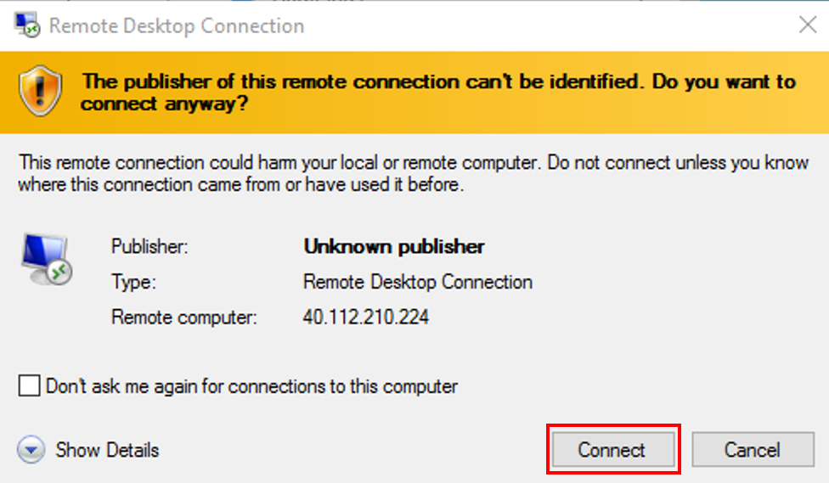

1. In the **Windows Security** dialog window, click **Use Another Account**.



1. Enter the credentials you created for your VM.

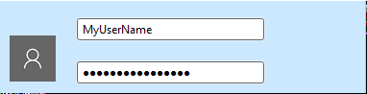

1. Check the **Remember My Credentials** checkbox.

C:\Users\PETERM~1\AppData\Local\Temp\SNAGHTML2ca3900.PNG

1. Click **OK**.
2. In the **Remote Desktop Connection** dialog window, check the **Don’t Ask Me Again for Connections to This Computer** checkbox.

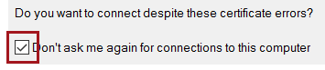

1. Click **Yes**.
2. If you have a second monitor, maximize the Remote Desktop window inside a single monitor.

# Setting Up the Azure VM

In this exercise, having connected to the VM, you will complete several setup tasks.

## Configuring the Server

In this task, you will configure the server to support the lab experience.

1. Notice that **Server Manager** has automatically opened.
2. In the left pane, select **Local Server**.

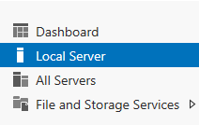

1. In the **Properties** pane, notice the **IE Enhanced Security Configuration** is set to **On**.

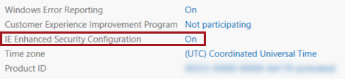

1. Click the **On** link.
2. In the dialog window, for **Administrators**, select the **Off** option.

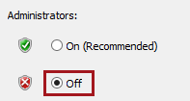

1. Click **OK**.
2. Located at the top-right corner, select **Manage**, and then select **Server Manager Properties**.



1. In the dialog window, check the **Do Not Start Server Manager Automatically at Logon**.

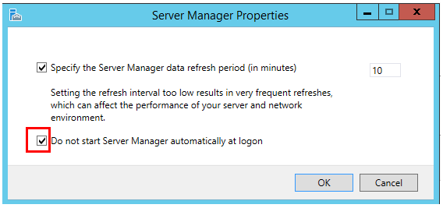

1. Click **OK**.
2. Close the Server Manager window.
3. To open the **Start** page, press the **Windows** key.
4. Right-click the **Internet Explorer** tile, and then select **Pin to Taskbar**.
5. To exit the **Start** page, press **Escape**.
6. Notice the **Internet Explorer** shortcut on the taskbar.

C:\Users\PETERM~1\AppData\Local\Temp\SNAGHTML2d53fd1.PNG

## Installing SQL Server Data Tools (SSDT)

1. Click the **Internet Explorer** shortcut.
2. In the **Internet Explorer 11** dialog window, go to the following URL: <https://msdn.microsoft.com/en-us/library/mt204009.aspx>
3. Select **Download SQL Server Data Tools for Visual Studio 2015!**

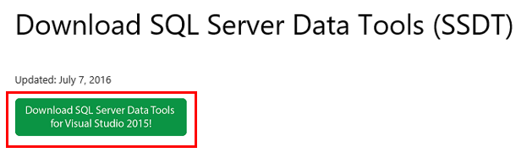

1. Scroll to **Download SSDT as an ISO Image (optional)** and select a **link** for download in your language of choice. In the image below we are selecting the English (United States) version.

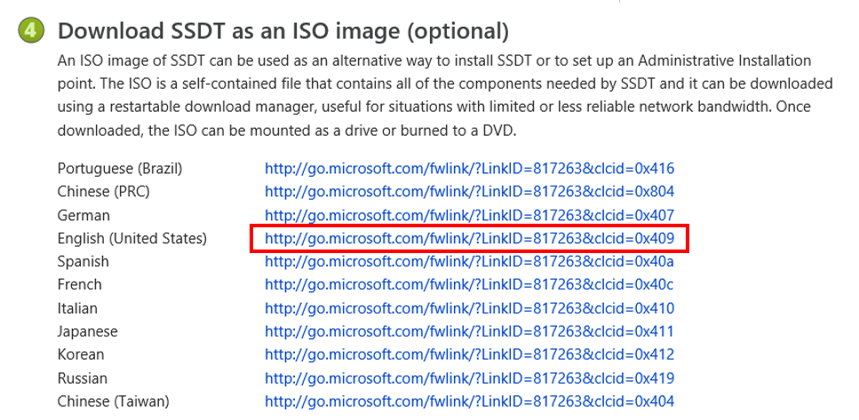

1. When the download is complete, select **Open**.



1. If it doesn’t open automatically, go to **File Manager.**



1. Under **DVD Drive (E:)**,select **SSDTSETUP**.

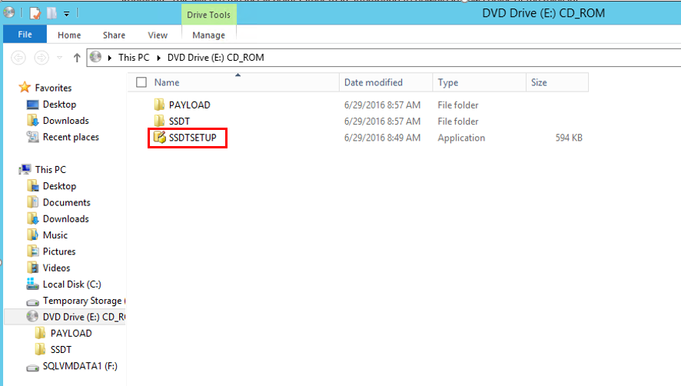

6. A dialog will open titled **Microsoft SQL Server Data Tools for Visual Studio 2015**, select **Next**.

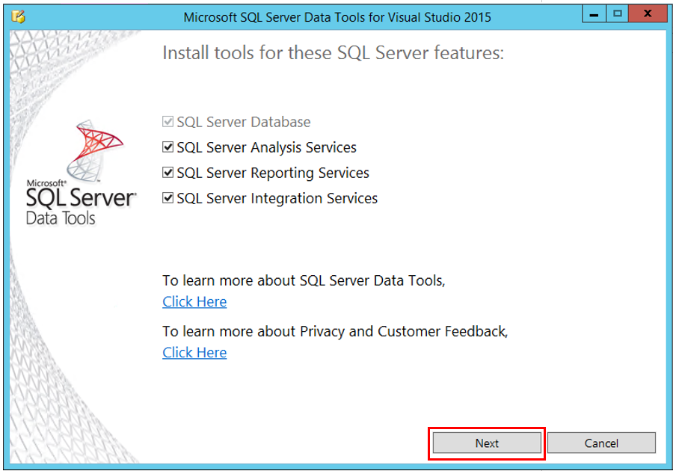

1. Choose whether or not you agree to the terms and conditions, and select **Install**. SSDT will be installed on your VM.
2. When installation is complete, you will see SQL Server Data Tools 2015 and Visual Studio 2015 have been installed in your apps.

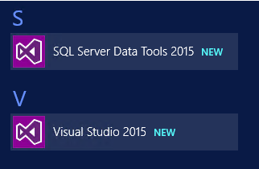

1. Your lab environment is now complete. You now have the option to complete the lab or deallocate your machine.

# IMPORTANT STEP | Deallocating your Machine

1. Return to the Azure Portal and select Virtual Machines.



1. Right click your **VM** and select **Stop**.

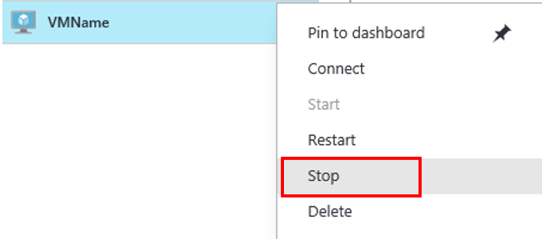

1. In the dialog **Stop this virtual machine**, select **Yes**.

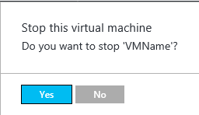

1. In the **Virtual machines blade**, confirm that your VM has been **stopped**.

